=(2016) Distinguish between UDP & TCP in terms of reliable data transfer, header size & connection overheads. [5 marks]

|  |  |  |
| --- | --- | --- |
|  | **TCP** | **UDP** |
| **Reliable?** | Very reliable | Unreliable |
| **Delivery?** | In-order | Unordered |
| **Header?** | 20-60 bytes (src port, dest port, seq num, ack num, data offset, reserved, control flags, window size, checksum, urgent data pointer, optional data) | 8 bytes (src port, dest port, length, checksum) |
| **Connection Overhead?** | Yes | No |

(2014) Explain the difference between TCP & UDP under the headings: Connection, Function, Usage, Reliability, Packet Ordering, Speed of transfer, Data Flow control, Error Checking, Handshake & Examples (e.g. HTTP = TCP). [20 marks]

|  |  |  |
| --- | --- | --- |
|  | **TCP** | **UDP** |
| **Connection** | P2P connection oriented | Connectionless |
| **Function** | Connection based | Used for message transport and transfer |
| **Usage(Suitable for)** | High reliability transmission | Fast, efficient transmission time |
| **Reliability** | Yes, (RDT) | None |
| **Packet Ordering** | In-Order | Out-Of-Order |
| **Speed of Transfer** | Slow | Fast(best-effort) |
| **Data Flow Control** | Set window size | None |
| **Error Checking** | Yes and recovery | Yes and no recovery |
| **Handshake examples(eg. HTTP = TCP)** | 3 way handshake (SYN, SYN-ACK, ACK) | None as connectionless |
| **Examples** | HTTP, telnet, ssh, ftp, smtp | VoIP, DHCP, DNS |

Describe the functionality provided by UDP & TCP. [5 marks]

Which one would you use for multimedia communications and why? [5 marks]

|  |  |  |
| --- | --- | --- |
|  | **TCP** | **UDP** |
| **Reliable?** | Very reliable | Unreliable |
| **Delivery?** | In-order | Unordered |
| **Header?** | 20-60 bytes (src port, dest port, seq num, ack num, data offset, reserved, control flags, window size, checksum, urgent pointer, optional data) | 8 bytes (src port, dest port, length, checksum) |
| **Connection Overhead?** | Yes | No |

The functionality provided by UDP and TCP are

UDP would be the preferred method for multimedia communications as it is

* Faster
* Reliability, in order transfer and error recovery isn’t as important
* Doesn’t need to be connection oriented

(2016) Would TCP or UDP be preferable for IP Telephony & IP Video Conferencing? Justify your answer. [5 marks]

**For IP telephony and videoconferencing**

|  |  |
| --- | --- |
| **TCP** | **UDP** |
| Must buffer for unacknowledged segments | Missing packets don’t affect quality that much, slight *slip of words* as packets get lost |
| Connection dies if too many packets are lost | Faster and better for real time |
| Line becomes garbled due to too many packets trying to recover |  |

(2016) A Web server using persistent connections is running on host C on port 80. It is receiving requests from both host A and B.

Are all the requests being sent through the same socket on host C?

If they are being passed through different sockets, do both the sockets have port 80? Discuss & Explain. [6 marks]

For a persistent connection, socket pairs are used, each socket pair is identified by the following..

* Source IP address
* Source port number
* Destination IP address
* Destination port number

And assigned a socket address. Once a host has received this numerical descriptor it can only then start communicating via this socket. For this reason, requests from A and B will always pass through different sockets. Although the destination port number (port 80) will be the same for A and B, the source IP address and possibly the port number will be different so would be given different socket addresses.

(2016) Draw the FSM for the receiver that corresponds to this sender's fsm. 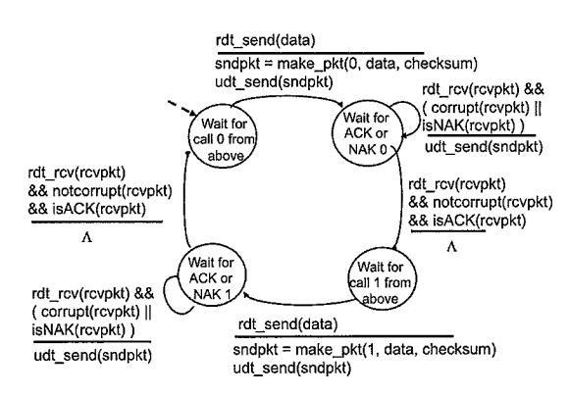

Receiver

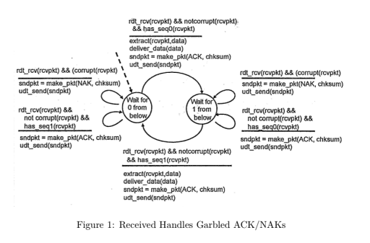

If host A sends two packets to host B, the first with sequence number 65 and the second with sequence number 92, how much data is in the first segment? [3 marks]

65 bytes as it is the first packet

If the first segment is lost and the second segment arrives, what will the ACK from B's acknowledgement number be? [3 marks]

ACK 93 as seq no. 92 is received, B is now expecting 92+1=93

Note: I emailed Hitesh about ^the above 2^ questions and this is the answers he gave me

(2016) With the aid of an example, describe the TCP 'Fast Retransmit' algorithm and its advantages. [8 marks]

Packets are sent back to back and lost packets are determined via duplicate ACKs

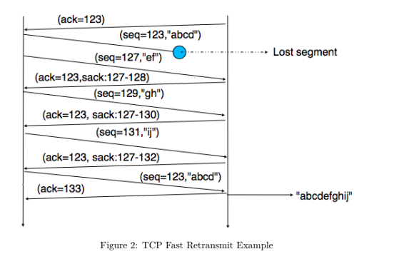

If sender received 3 ACKs from the same data commonly referred to as Triple Duplicate ACKs, resent segment of that sequence number, do not wait for the timeout as can be relatively long.

(2016) Why is TCP congestion control referred to as an additive-increase, multiplicative-decrease (AIMD) form of congestion control? [8 marks]

The congestion window determines the maximum amount of bytes that can be outstanding at any given time and is set to the Maximum segment size (MSS) allowed on the connection.

If all segments are received and ACKs reach the sender on time the congestion window is increased by 1 MSS. If a packet is lost the congestion window is cut in half.

